

II. Textbook: II. Textbook: Duiker & Spielvogel, *World History* (Wadsworth Cengage Learning 2013) Seventh Edition. ISBN 978-1-111-83765-5.

edition.

# *Those who cannot learn from history are doomed to repeat it.* -George Santayana

Dual Enrollment: World Civilization II

## HIST: 1120

Mrs. Cleveland

I. Instructor- Jaclyn Cleveland

Peter Stearns sums it up nicely with the following: “Why study history? The answer is because we virtually must, to gain access to the laboratory of human experience. When we study it reasonably well, and so acquire some usable habits of mind, as well as some basic data about the forces that affect our own lives, we emerge with relevant skills and an enhanced capacity for informed citizenship, critical thinking, and simple awareness. The uses of history are varied. Studying history can help us develop some literally "salable" skills, but its study must not be pinned down to the narrowest utilitarianism. Some history-that confined to personal recollections about changes and continuities in the immediate environment-is essential to function beyond childhood. Some history depends on personal taste, where one finds beauty, the joy of discovery, or intellectual challenge. Between the inescapable minimum and the pleasure of deep commitment comes the history that, through cumulative skill in interpreting the unfolding human record, provides a real grasp of how the world works.”

Tutoring Hours:

Seminar Time

7:10 a.m. before exams

By appointment

Why Study History?

## Course Goals

## History?

When you finish this course, you will be a better thinker, communicator, researcher, writer, problem solver, and reader. As we study history this year, you will be asked to read complex texts, research historical topics, create research papers and presentations, collaborate with peers to discuss and solve problems, analytically write about history and its ramifications to today, and much more. You will understand connections between historical events and events that are unfolding on the news each day. You will leave this course with the ability to understand and even enjoy life more.

Spring 2015

[clevelandj@monroe.k12.tn.us](mailto:price_jaclyn@hotmail.com)  
Room #203   
423.337.7881   
www.clevelandhistory.weebly.com

Room #203

Mrs. Cleveland

|  |  |
| --- | --- |
| VII. | Attendance Policy |

When students miss class, it is their responsibility to obtain and turn in their make-up work. If a student misses on a date when there is a test or project due, then this will be due the first day the student returns to class.

**V. Assessment & VI. Evaluation and Grading Procedures**

**Final National History Day Project = 200 points**

**4 Exams** = 400 points

Exam #1:  
Exam #2:  
Exam #3:  
Exam #4:

**Visual Presentation** = 50 points   
Due Date:

**Website Design** or **3 page MLA Research Paper** = 150 points

**Book Review & Presentation** = 100 points   
Due Date:

**Classroom Assignments**= 100 points

This grade includes classroom assignments and quizzes.

**III. Course Overview:**  A survey of human history from 1500 to the present, with emphasis on key cultural, economic, political, religious and social events and trends. Three hours per week. (Prerequisite(s): All required learning support reading courses.) F, S, Su

**IV. Learning Outcomes**

Students will demonstrate the ability to:

https://elearn.clevelandstatecc.edu/content/enforced/5869790-80939.201480/bluesquare2.gif?_&d2lSessionVal=vF3pmip63JegxhowTzIIRgzFc&ou=5869790  Analyze historical facts and interpretations.

https://elearn.clevelandstatecc.edu/content/enforced/5869790-80939.201480/bluesquare2.gif?_&d2lSessionVal=vF3pmip63JegxhowTzIIRgzFc&ou=5869790  Analyze and compare political, geographic, economic, social, cultural, religious, and intellectual institutions, structures, and processes across a range of historical periods and cultures.

https://elearn.clevelandstatecc.edu/content/enforced/5869790-80939.201480/bluesquare2.gif?_&d2lSessionVal=vF3pmip63JegxhowTzIIRgzFc&ou=5869790  Recognize and articulate the diversity of human experience throughout history and the complexities of a global culture and society.

https://elearn.clevelandstatecc.edu/content/enforced/5869790-80939.201480/bluesquare2.gif?_&d2lSessionVal=vF3pmip63JegxhowTzIIRgzFc&ou=5869790  Draw on historical perspective to evaluate contemporary problems/issues.

https://elearn.clevelandstatecc.edu/content/enforced/5869790-80939.201480/bluesquare2.gif?_&d2lSessionVal=vF3pmip63JegxhowTzIIRgzFc&ou=5869790  Demonstrate a comprehension of contributions and experiences of various regions, ethnicities, races, and genders in the creation of the modern world.

Mrs. Cleveland

Mrs. Cleveland

Room #203

|  |
| --- |
|  |
| X. | Academic Integrity: |
|  | Cleveland State students are required, as a condition of good standing and continued enrollment, to conduct themselves properly in class. Such proper behavior includes academic honesty, civility, and respect for others and private property. Please refer to the Student Handbook portion of the catalog for further information. |

**Class Policies**

Room 203

Mrs. Cleveland

**Be on time:** Being on time is essential to your success. Arriving late puts you behind and disrupts our classroom activity. You should be taking out your materials and beginning the daily work posted on the board when the bell rings.

**Be prepared:** Bring all necessary materials to class every day including homework, textbook, paper, writing utensil, and notebook. You do not need to rely on classmates to supply your school needs. Be responsible! On the rare occasion you do forget something, do not interrupt the lesson to ask for it. Ask a friend or check the supply table first.

**Act appropriately.**  
You are expected to follow all school policies in this classroom and each classroom you enter. Here are some examples of acting appropriately in class:  
a. Raising your hand to speak.  
b. Staying in your seat unless permission is granted to move.   
c. Using only appropriate language, no cursing or put-downs.   
d. Respecting others and their property.

**Do your best.**High School is what you make of it. You can choose to listen in class, complete assignments, study, and participate in school and you will benefit tremendously. You can also choose to not do anything and this will only hurt you. It is your choice, but **your future** hinges on the decisions you make **today**.

**VIII. Disability Statement**

If because of a documented disability you will be requesting assistance or accommodations to complete the assigned work, please inform me and contact the Student Development Center, which provides these services for any student with a disability. The phone number of the Student Development Center is (423) 478-6217. It is your responsibility to make all such requests, and you should do so as soon as possible in order to come to an agreement with me early in the semester about the services to be provided and to receive the maximum benefit from these services.

**IX. Withdrawal Information**

If you would like to withdraw from this class, contact Cleveland State Community College before the deadline.

|  |
| --- |
|  |
| X. | Academic Integrity: |
|  | Cleveland State students are required, as a condition of good standing and continued enrollment, to conduct themselves properly in class. Such proper behavior includes academic honesty, civility, and respect for others and private property. Please refer to the Student Handbook portion of the catalog for further information. |

|  |
| --- |
|  |
| X. | Academic Integrity: |
|  | Cleveland State students are required, as a condition of good standing and continued enrollment, to conduct themselves properly in class. Such proper behavior includes academic honesty, civility, and respect for others and private property. Please refer to the Student Handbook portion of the catalog for further information. |

|  |
| --- |
|  |
| X. | Academic Integrity: |
|  | Cleveland State students are required, as a condition of good standing and continued enrollment, to conduct themselves properly in class. Such proper behavior includes academic honesty, civility, and respect for others and private property. Please refer to the Student Handbook portion of the catalog for further information. |

**Sweetwater High School’s Grading System**

A=93-100

B=85-92

C=75-84

D=70-74

F=69 or below

**A = 90-100**

**B = 80-89**

**C = 70-79**

**D = 60-69**

**F = below 60**

**Cleveland State Community College Grading System**

**CONSEQUENCES:**  Students who do not follow school rules and class policies will be subject to various consequences.

Students who are a disruption to the learning process will be removed from the class.  
1. Warning   
2. Private Conference with Teacher  
3. Detention with Teacher  
4. Private Conference with Teacher and Parent  
 5. Office – In School or Out of School Suspension Possible  
*Depending on the offense, some levels may be bypassed or repeated.

**X. Academic Integrity:** Cleveland State students are required, as a condition of good standing and continued enrollment, to conduct themselves properly in class. Such proper behavior includes academic honesty, civility, and respect for others and private property. Please refer to the Student Handbook portion of the catalog for further information.

**XI. Computer Skills:** Content and/or assignments for this course may require the use of computers, media equipment, or access to the internet. If you believe you might lack the technical skills necessary to succeed in the class, advise the instructor immediately. In consultation with the instructor you may consider exploring one of the following options: the eLearning lab, library resources, the Reading and Writing Center, or taking a computer class for credit.

**It’s not about how many historical facts you can memorize in this class. It’s how deep you go. Students often sign up for this course only because ‘it’s required’ to graduate. Consider why numerous educated adults deemed it necessary for you to take this course and what exactly does that mean for you on a personal level. It would be completely plausible for you to complete this course with a good grade without being transformed by your newfound historical knowledge and your honed analytical skills. But that would be such a waste! Imagine we are standing on the seashore; the course is the ocean. Enter with me and go as deep as you dare…**

**XII. How to take this course:**

You have a grasp of the basics and are ready to think historically and explore what’s below the surface.

Perhaps you are a major history buff. You already know that history is a conversation among differing and/or contradictory perspectives.

‘Snorkelers’ notice historical inconsistencies and they respectfully challenge assumptions through lively debate. Snorkelers are interested in HOW & WHY things happened as they did.

Snorkeling

Mrs. Cleveland

Room 203

Scuba Diving

You want to go deeper into the past, using the cognitive equipment and tools of history as a focused critical thinker.

Experienced? You are well aware of historical controversy and how historical knowledge is constructed. You actively seek alternative sources, interpretations, and voices.

‘Divers’ don’t take any course’s structure or content as natural or inevitable. They see (and then fill) the courses’ gaps. They are curious, passionate, and concerned with WHY HISTORY MATTERS.

You need the basic outlines of history, highlights, main characters, and ideas, and basically surface level knowledge.   
  
There’s nothing wrong with staying in the shallows; this approach may work for you if this is the only history course you ever need to take. It may also have to work for you if everything is new to you.   
  
‘Waders’ will tend to assume that textbook, documents, and teachers are all mutually reinforcing, telling basically the same story. Waders are mainly concerned with WHAT happened in the past.

Scuba Diving

Wading

Snorkeler

.

Mrs. Cleveland

Room 203

[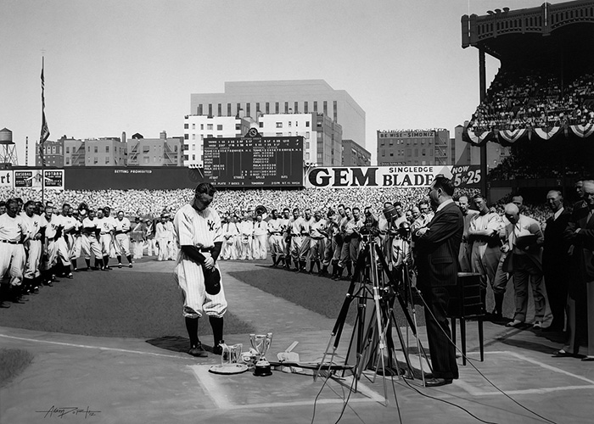](http://cdn.rsvlts.com/wp-content/uploads/2015/06/The-Luckiest-Man-Large.jpg)

**XIII. Additional Readings**

These will occur frequently and will be made available in print or online.   
Students are responsible for all assigned material and can expect frequent quizzes over the  
 material.

**XIV. Classroom Courtesy**

Please do not bring homework from other classes to work on during my class. Cell-phones and other electronics are to be kept out of sight and not used during class unless instructed to do so. The bell does not dismiss you. I will dismiss you each day. Raise your hand and wait on the teacher to call on you. You must also stay awake during class.

**XV. Required Supplies**

1. Paper 2. Pencil/Pen 3. 2-3 inch thick 3 Ring binder 4.Flash drive is recommended

**XVI. Daily Questions**

Daily Questions will be on the board each day at the start of class. This will be the opening activity. Students will immediately begin the daily questions by writing the question and answer in their notebook. Students are still to write the questions even if they don't know the answers.

**XVII. Make-Up Policy**

If you are absent from class, it is your responsibility to find out what you missed. Do not expect to interrupt instructional time to obtain your assignments. You can ask a friend or me during a convenient time. Seminar is an excellent time to work on make-up work. We can also set up a time before or after school. Any work that is not completed will result in a 0. It is not wise to wait until the end of the grading period to gather make-up work.

**XVIII. Taking Notes in Class**

Note taking is a critical part of this class. Notes will usually be on the Promethean board to help with spelling and accuracy. Notes are to be dated and filed in student notebooks. Students are not to talk during notes unless they raise their hand and are called on by the teacher. All comments and questions must be relevant.

**XIX. Pop Quizzes**

We will often have pop quizzes. Quizzes will be over notes, assigned reading, video clips, and other classroom activities. It is your responsibility to come to class prepared each day.

**XX. Food and Drink**

Each class is allowed to eat and drink in class until it becomes a disruption or that class leaves behind a mess. Please throw away your trash as you exit the classroom.

**XXIII. Emails**

All emails should include SHS DE HISTORY I in the subject line.

I reserve the right to make changes as necessary to this syllabus. If changes are needed during the term of the course, I will immediately notify students of such changes through my website, email, and/or a phone call.

If you would like to bring in any of the below items for our classroom, it would be greatly appreciated. No extra credit will be given. Students who donate items will receive a homework pass.

**Class Wish List**

Kleenex

Hand Sanitizer

Dry Erase Markers

Pencils

Good Ink Pens

College Rule Paper

Highlighters

Appropriate Books: Fiction or Non-Fiction

Tape

Computer paper

Mrs. Cleveland

Room 203

**XXI. Class Website**

Check out the class website to stay up to date. There are numerous helpful resources on this site. [www.clevelandhistory.weebly.com](http://www.clevelandhistory.weebly.com/)  
  
**XXII. Extra Credit**

There will be no extra credit opportunities in Dual Enrollment Courses.

|  |
| --- |
| TIPS FOR SUCCESS |
| * Take notes during class and then keep up with those notes. * If you are struggling with a class, go to that teacher immediately and ask how you can better prepare for their class. * Do not wait until the end of the grading period. It is too late then. * Be polite. * Use seminar time wisely. You can finish your homework, prepare for tests, and receive tutoring.   Horace Mann said that, “Education is the great equalizer.” This is an accurate statement. No matter your current situation, whether it is wonderful or terrible, the education you obtain today has the potential to change that. Each decision you make today will have consequences tomorrow. Choose wisely. If you need help, ask a teacher. We are here to help you be successful. We are on your team and want the best for your future! |

Metacognition – Think about how you think.

**Bloom’s Taxonomy**

[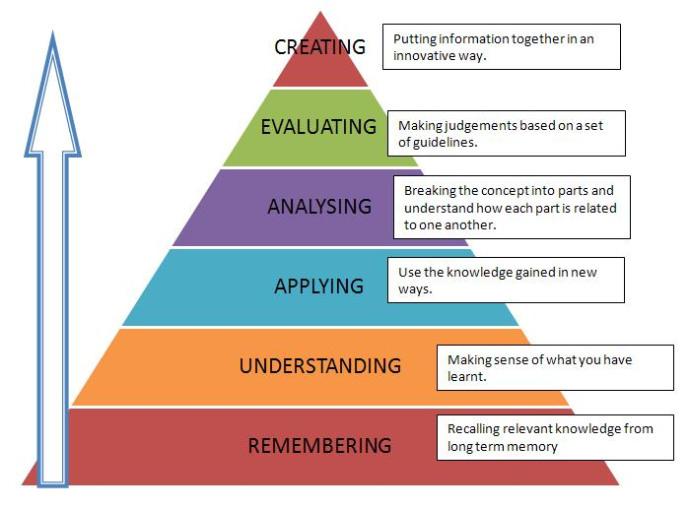](https://www.flickr.com/photos/53801255@N07/7095644699)

[](https://www.flickr.com/photos/53801255@N07/7095644699)

Mrs. Cleveland

Room 203