Explain the significant roles played by muckrakers and progressive idealists during the late 19th and early 20th centuries.
- Discuss the specific problems "muckrakers" exposed in the late 19th and early 20th centuries?
- What reforms did federal and state governments enact during the Progressive Era?
- Use evidence from these sources and your content knowledge to support your answer.
Document 1
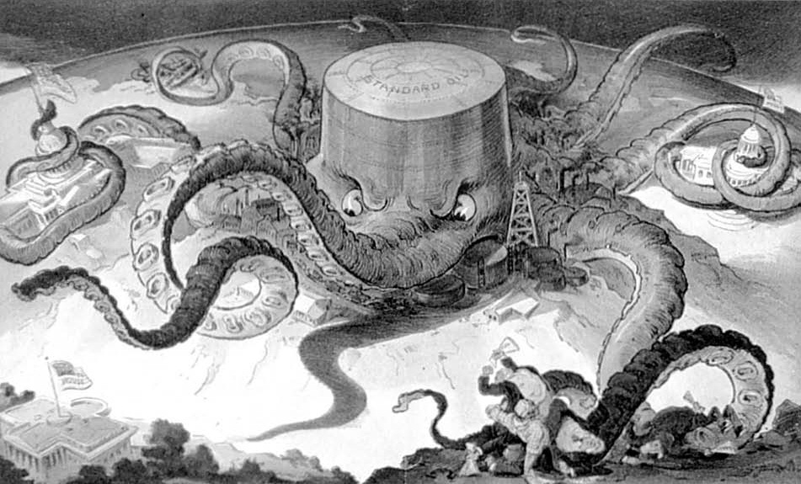
Source: Public Domain/ Library of Congress

Document 2

In the fall of 1871, while Mr. Rockefeller and his friends were occupied with all these questions, certain Pennsylvania refiners, it is not too certain who, brought to them a remarkable scheme, the gist of which was to bring together secretly a large enough body of refiners and shippers to persuade all the railroads handling oil to give to the company formed special rebates on its oil, and drawbacks on that of other people. If they could get such rates it was evident that those outside of their combination could not compete with them long and that they would become eventually the only refiners. They could then limit their output to actual demand, and so keep up prices. This done, they could easily persuade the railroads to transport no crude for exportation, so that the foreigners would be forced to buy American refined. They believed that the price of oil thus exported could easily be advanced fifty per cent. The control of the refining interests would also enable them to fix their own price on crude. As they would be the only buyers and sellers, the speculative character of the business would be done away with. In short, the scheme they worked out put the entire oil business in their hands. It looked as simple to put into operation as it was dazzling in its results. Mr. Flagler has sworn that neither he nor Mr. Rockefeller believed in this scheme. But when they found that their friend Peter H. Watson, and various Philadelphia and Pittsburg parties who felt as they did about the oil business, believed in it, they went in and began at once to work up a company-secretly. It was evident that a scheme which aimed at concentrating in the hands of one company the business now operated by scores, and which proposed to effect this consolidation through a practice of the railroads which was contrary to the spirit of their charters, although freely indulged in, must be worked with fine discretion if it ever were to be effective.

Document 3
With one member trimming beef in a cannery, and another working in a sausage factory, the family had a first-hand knowledge of the great majority of Packingtown swindles. For it was the custom, as they found, whenever meat was so spoiled that it could not be used for anything else, either to can it or else chop it up into sausage. With what had been told them by Jonas, who had worked in the pickle rooms, they could now study the whole of the spoiled meat industry on the inside, and read a new and grim meaning into that old Packingtown jest — that they use everything of the pig except the squeal.

Document 4

I stand for the square deal. But when I say that I am for the square deal, I mean not merely that I stand for fair play under the present rules of the game, but that I stand for having those rules changed so as to work for a more substantial equality of opportunity and of reward for equally good service. One word of warning, which, I think, is hardly necessary in Kansas. When I say I want a square deal for the poor man, I do not mean that I want a square deal for the man who remains poor because he has not got the energy to work for himself. If a man who has had a chance will not make good, then he has got to quit. And you men of the Grand Army, you want justice for the brave man who fought, and punishment for the coward who shirked his work. Is that not so?

Document 5

The Senate of the United States shall be composed of two senators from each state, elected by the people thereof, for six years; and each senator shall have one vote. — 17th Amendment to the United States Constitution (1913)

