Standard:

Using multiple sources and diverse formats, summarize the impact of the mass production and widespread availability of automobiles on the American economy and society.

Explain the impact of the automobile during the 1920s.
- How did the production of the automobile increase during the 1920s?
- How did the automobile impact American society and the economy during the 1920s?
- Use evidence from these sources and your content knowledge to support your answer.

Document 1
A Ford car contains about five thousand parts—that is counting screws, nuts, and all. Some of the parts are fairly bulky and others are almost the size of watch parts. In our first assembling we simply started to put a car together at a spot on the floor and workmen brought to it the parts as they were needed in exactly the same way that one builds a house. When we started to make parts it was natural to create a single department of the factory to make that part, but usually one workman performed all of the operations necessary on a small part. The rapid press of production made it necessary to devise plans of production that would avoid having the workers falling over one another…. The first step forward in assembly came when we began taking the work to the men instead of the men to the work. We now have two general principles in all operations—that a man shall never have to take more than one step, if possibly it can be avoided, and that no man need ever stoop over. …In short, the result is this: by the aid of scientific study one man is now able to do somewhat more than four did only a comparatively few years ago. That line established the efficiency of the method and we now use it everywhere. The assembling of the motor, formerly done by one man, is now divided into eighty-four operations—those men do the work that three times their number formerly did.

Document 2

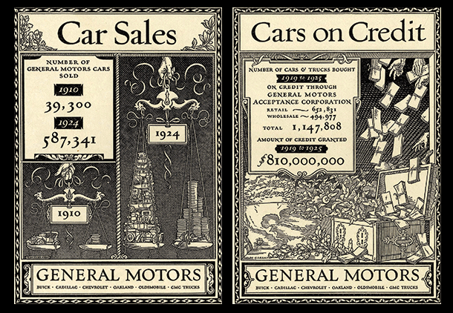

Document 3

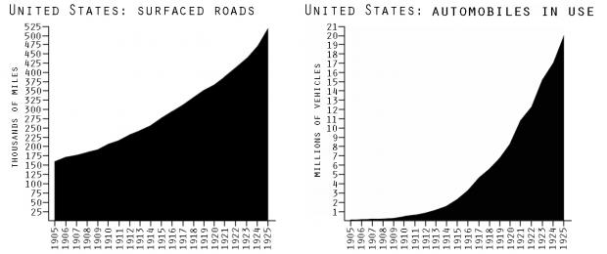

Document 4

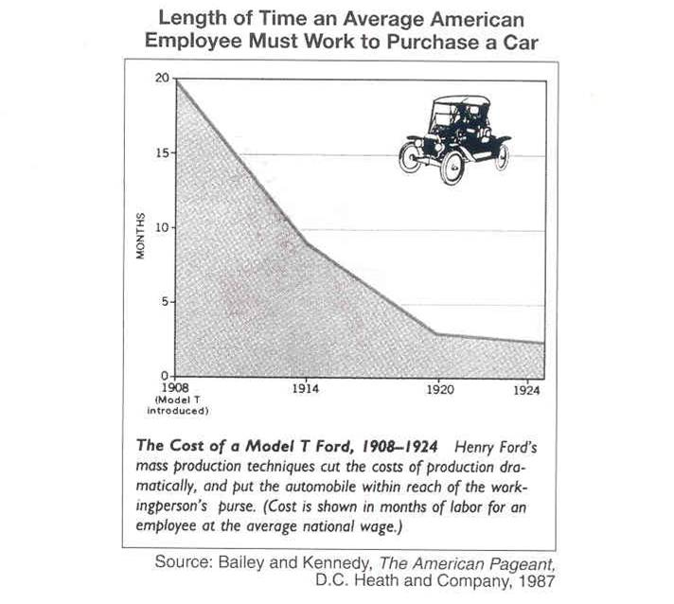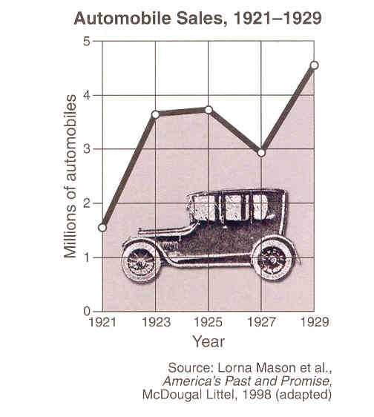

Document 5
No one of us can measure such a development in transportation. We have in 1921 about nine million motor cars in the United States, hardly a third as many as our horses. Yet I think there can be no serious question that the motor car has come to be more important to us socially than the horse. The most comprehensive change it has wrought for us has been the general widening of the circle of our life. City folk feel this in the evening and at the weekend. Farmer folk feel it from early morning till bedtime every day. . . . Farm men race to town to meetings of the farm bureau, farm women to meetings of the domestic science [homemaking] clubs; all of them to the circus or the movies or the winter concert season. In our youth such expeditions would have required half a day in travel. In our motoring middle life, they require less than half an hour each way. . . . Strange-looking driveways called “filling stations” with glowing lamps at night, long railroad trains of tankcars, streets painted with white lines to mark zones of safety for pedestrians and parking spaces for cars—how almost without a pause in our thinking have we adjusted our lives to these factors new since yesterday!

