Psychology Study Guide

Memorize & Evaluate:
-Piaget’s Stages of Coginitive Development
-Kohlberg’s Levels of Moral Development
-James Marcia’s Identity Status Categories
-Erik Erikson’s Pyschosocial Development

The below charts and info should be studied in addition to your notes and charts created in class.

James Marcia’s Identity Status Categories
Identity Foreclosure- Conforming, accepting childhood identity and values, identifying with others, making commitments and plans without self-examination, becoming inflexible
Identity Achievement – exploring options, committing to direction in life and occupation, finding own identity
Identify Diffusion – making no commitment, no soul searching, no goals, angry and rebellious
Identity Moratorium – searching for identity, exploring alternatives, delaying commitments

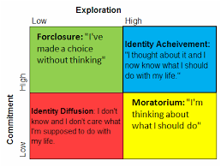

James Marcia is another influential theorist who expanded upon Erikson's concept of identity crisis and identity confusion. His initial work was published during the 1960's but his theory continues to be refined in accordance with recent research findings. Although Marcia's theory originally conceptualized identity development in terms of a progressive developmental trend, his theory has subsequently become more descriptive and categorical, defining and identifying particular configurations of identity exploration and commitment.
Marcia's theory descriptively categorizes four main points or stations along the continuum of identity development. These stations or points describe very different identity conditions, ranging from a diffuse and indeterminate individual identity to a precisely defined and highly specific individual identity. Similar to Erikson, Marcia believed that certain situations and events (called "crises") serve as catalysts prompting movement along this continuum and through the various identity statuses. These crises create internal conflict and emotional upheaval, thereby causing adolescents to examine and question their values, beliefs, and goals. As they explore new possibilities, they may form new beliefs, adopt different values, and make different choices. According to Marcia's theory, these developmental crises ultimately cause adolescents to develop a progressively greater commitment to a particular individual identity via the process of identity exploration prompted by developmental crises.

Marcia used the term identity status to label and describe four unique developmental identity stations or points. These are: identity diffusion, identity foreclosure, moratorium and identity achievement. Each identity status represents a particular configuration of youth's progress with regard to identity exploration and commitment to the values, beliefs, and goals that contribute to identity. Though the different identity statuses are in some sense progressive (in the sense that they flow one to the next), Marcia's theory does not assume that every adolescent will pass through and experience all four identity statuses. Some youth may experience only one or two identity statuses during adolescence. Additionally, there is no assumption that a youth's identity status is uniform across all aspects of their development. Youth may have different identity statues across different domains such as work, religion, and politics. In this sense it is possible for youth to have more than one identity status at a time. Furthermore, unlike Erickson's stage theory, Marcia's theory accounts for multi-directional movement between and among the various identity statuses. For instance, youth may experience a traumatic event such as parental divorce, or a violent assault, which may cause them to re-evaluate their understanding of the world and their value system. This type of crisis may cause them to retreat to a previously enacted identity status as they integrate this new information.
(https://www.mentalhelp.net/articles/james-marcia-and-self-identity/)

Piaget’s Stages of Cognitive Development
20th-century scholar Jean Piaget created highly influential theories on the stages of mental development among children, becoming a leading figure in the fields of cognitive theory and developmental psychology.
QUOTES
“The goal of education is not to increase the amount of knowledge but to create the possibilities for a child to invent and discover, to create men who are capable of doing new things.”
—Jean Piaget

Synopsis
Jean Piaget was born on August 9, 1896, in Neuchâtel, Switzerland, becoming an expert on the study of mollusks by his teen years. Over the course of his later career in child psychology, he identified four stages of mental development that chronicled young people's journeys from basic object identification to highly abstract thought. The recipient of an array of honors, Piaget died on September 16, 1980, in Geneva, Switzerland. (http://www.biography.com/people/jean-piaget-9439915)
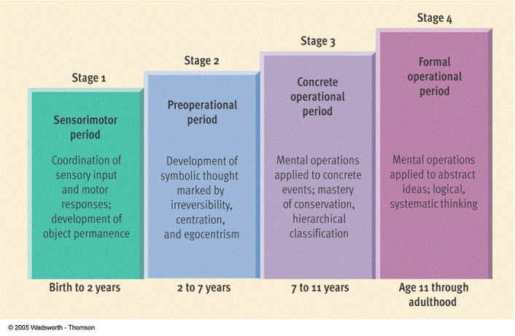

Erik Erikson’s Psychosocial Development
Personality development, in Erik H. Erikson's view, occurs through a series of identity crises that occur in stages that must be overcome and internalized.
Erik H. Erikson immigrated to the United States in 1933, where he practiced child psychoanalysis and joined the Harvard Medical School faculty. In 1936 he moved to Yale, and in 1938 he began his first studies of cultural influences on psychological development. He later taught at U.C. Berkeley, but left in 1950. In his view, personality development takes place through a series of identity crises. (http://www.biography.com/people/erik-h-erikson-37751#synopsis)
Know the stages!

Kohlberg’s Stages of Moral Development
Preconventional
- Avoiding Punishment – doing what is necessary to avoid punishment
- Satisfying needs – doing what is necessary to satisfy one’s needs

Conventional
- Winning approval – seeking and maintaining the approval of others using conventional standards of right and wrong
- Law and Order – Moral judgments based on maintaining social order/High regard for authority

PostConventional
5. – Social Order – obedience to accepted laws, judgments based on personal values
6. Universal Ethics – morality of individual conscience, not necessarily in agreement with others

Contribution to Psychology
Kohlberg’s stages of moral development were influenced by the Swiss psychologist Jean Piaget’s stage-based theory of development. Kohlberg expanded on Piaget’s two stages, identifying six stages of moral development. He argued that correct moral reasoning was the most significant factor in moral decision-making, and that correct moral reasoning would lead to ethical behavior. Kohlberg believed that individuals progress through stages of moral development just as they progress through stages of cognitive development.
Kohlberg’s theory of moral development included three levels and six stages:
- Preconventional Morality:
  - Stage one: Obedience and punishment. The child is motivated to avoid punishment and has little or no independent moral reasoning.
  - Stage two: Individualism and exchange. Individuals are focused on fulfilling their own self-interests, while acknowledging that different people have different views.
- Conventional Morality:
  - Stage three: Maintaining interpersonal relationships. At this stage, individuals emphasize the importance of being kind to other people, engaging in “good” behavior and showing concern for others. This stage includes a strong emphasis on gaining approval.
  - Stage four: Law and order. The individual is determined to obey the rules, focusing on the value that the law adds to human life. A person at this stage might argue that breaking the law is wrong because the law is designed to protect people. Stage 4 individuals focus on maintaining the social order and upholding cultural norms.
- Post-Conventional Morality
  - Stage five: Social contract. People at this stage of development focus on doing what is best for society as a whole and respecting individual rights. Civil disobedience would be endorsed by people in both stages of post-conventional morality.
  - Stage six: Universal principles. At this stage, individuals are focused on upholding principles of universal justice, fairness, and ethics. They believe in the democratic process, but also endorse disobeying unjust laws.
To determine which stage of moral development his subjects were in, Kohlberg presented them with invented moral dilemmas, such as the case of a man who stole medicine for his sick wife. According to Kohlberg, few people reach stages five and six; most tend to stay at stage four.

Criticism and Controversy
Kohlberg purported that women were often at a lower stage of moral development than men, but psychologist Carol Gilligan questioned his findings. Gilligan claims that women place a strong emphasis on caring and empathy, rather than on justice. She developed an alternative scale, heavily influenced by Kohlberg's scale, that showed that both men and women could reach advanced stages of moral development.

(http://www.goodtherapy.org/famous-psychologists/lawrence-kohlberg.html)

